230701286 G.SANJAY

WEEK 3:

1. i) Problem Statement

This problem to understand the nested loop. Given N, a Positive integer, You are

supposed to print the alternating 1’s and 0’s in triangle format.

Input Format :

Input is positive integer : 5

Output Format:

1

0 1

1 0 1

0 1 0 1

1 0 1 0 1

PROGRAM:

import java.util.Scanner;

import java.util.\*;

public class demo

{

public static void main(String a[])

{

int rows=5;

for(int i=1;i<=rows;i++)

{

int num=i%2;

for(int j=1;j<=i;j++)

{

System.out.print(num+" ");

num=1-num;

}

System.out.println();

}

}

}

OUTPUT:

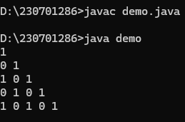

ii) Number-increasing reverse Pyramid Pattern

Given N, a Positive integer, You are supposed to print in the below format.

Sample Input:

6

Sample Output:

1 2 3 4 5 6

1 2 3 4 5

1 2 3 4

1 2 3

1 2

1

PROGRAM:

import java.util.\*;

public class demo

{

public static void main(String a[])

{

Scanner c=new Scanner(System.in);

int n=c.nextInt();

for(int i=n;i>=1;i--)

{

for(int j=1;j<=i;j++)

{

System.out.print(j+" ");

}

System.out.println();

}

}

}

OUTPUT:

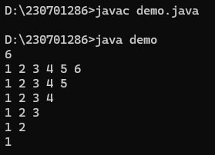

2. Identify the Weekday or Weekend

Problem Statement:

SYNTAX OF SWITCH CASE

The general syntax for a switch case in Java is as follows:

switch (expression) {

case value1:

// Code to be executed if expression equals value1

break;

case value2:

// Code to be executed if expression equals value2

break;

// ...

default:

// Code to be executed if expression doesn&#39;t match any case values

}

You are developing a scheduling application where users can check whether a

given day is a weekday or a weekend. The application should prompt the user to

enter a day of the week (e.g., &quot;Monday&quot;, &quot;Saturday&quot;), and based on the input, the

program should determine if the day is a weekday or a weekend.

Input Format

Input consists a week of the day

Output Format

Print whether it is weekday or weekend or invalid day

Sample Input 1

Monday

Sample Output 1

It’s a weekday

Sample Input 2

Sunday

Sample Output 2

It’s a weekend

PROGRAM:

import java.util.Scanner;

public class demo

{

public static void main(String a[])

{

Scanner c=new Scanner(System.in);

String b=c.nextLine();

switch(b)

{

case "monday":

System.out.println("it's weekdays");

break;

case "tuesday":

System.out.println("it's weekdays");

break;

case "wednesday":

System.out.println("it's weekdays");

break;

case "thursday" :

System.out.println("it's weekdays");

break;

case "friday":

System.out.println("it's weekdays");

break;

case "saturaday":

System.out.println("it's weekdays");

break;

default:

System.out.println(" it's weekend");

}

}

}

OUTPUT:

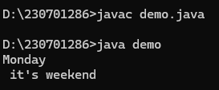

3. Strong Number

Problem Statement:

Write a program to check whether a number is a Strong Number or not.

A strong number is a positive integer whose sum of the factorials of its digits

equals the original number

Few examples of strong numbers are : 1,2,145 and 40585.

Input Format:

Read the positive number

Output Format:

Print Whether it is strong number or not.

Sample Input 1:

145

Sample Output 1:

Strong number

PROGRAM:

import java.util.Scanner;

public class demo

{

public static void main(String a[])

{

Scanner c=new Scanner(System.in);

int n=c.nextInt();

int temp=n;

int i,fact;

int sum =0;

int rem;

while(n!=0)

{

i=1;

fact=1;

rem=n%10;

while(i<=rem){

fact=fact\*i;

i++;

}

sum=sum+fact;

n=n/10;

}

if(sum==temp)

{

System.out.println("it's strong");

}

else

{

System.out.println("it's not strong");

}

}

}

OUTPUT:

